The open university of Israel
Department of Mathematics and Computer Sciences

Speaker age estimation based on acoustic speech signal

Thesis submitted as partial fulfillment of the requirements towards a M.Sc. degree in computer sciences.
The Open University of Israel
Computer Science Division

By
Gil Dobry

Prepared under the supervision of Dr. Yaniv Zigel
and Dr. Mireille Avigal

November 2009

האוניברסיטה הפתוחה
המחלקה למתמטיקה ומדעי המחשב

זיהוי גיל דובר על פי אות דיבור

עבודת תזה זו הוגשה כחלק מהדרישות לקבלת תואר
מוסמך למדעים M.Sc במדעי המחשב
באוניברסיטה הפתוחה
החטיבה למדעי המחשב

ע"י
גיל דוברי

העבודה הוכנה בהדרכתם של ד"ר יניב ציגל וד"ר מיריי אביגל

נובמבר 2009

Ackowledgements

I would like to thank my dear wife Natalya, for her support, encouragement and patience during this thesis preparation.
Also, I would like to thank Dr Yaniv Zigel, Dr Mireille Avigal and Ron Hecht for their guidance, advice and everything I could learn from their rich experience in speech analysis, pattern recognition and academic text preparation.

Table of contents

1 Introduction 12
1.1 Objectives 12
1.1.1 Dimension reduction 12
1.1.2 Age estimation by age-group classification 13
1.1.3 Age estimation by regression 13
1.2 Related publications 14
1.3 Paper organization 14
2 Literature survey 15
2.1 Age estimation background 15
2.2 GMM supervectors framework 17
2.3 Dimension reduction 18
2.3.1 Principal Components Analysis 18
2.3.2 Linear discriminant analysis 20
2.3.3 Nuisance attributes projection 22
2.3.4 Anchor modeling 24
3 Age estimation system 26
3.1 Feature extraction and dimension reduction 27
3.1.1 Training the UBM 28
3.1.2 Adaptation of the speaker’s model 29
3.1.3 Building the supervector 30
3.2 Age estimation by classification. 32
3.3 Age estimation by regression 35
4 Dimension reduction approaches 37
4.1 Principle components analysis 37
4.2 Supervised PCA 37
4.3 Weighted pairwise PCA 38
4.3.1 Projection matrix 38
4.3.2 Weights matrix calculation 39
4.4 Anchor modeling 41
4.4.1 Projection matrix 41
4.4.2 Anchor-supervectors selection 42
5 SVM algorithms complexity 43
5.1 SVM training 43
5.2 SVM testing 44
6 Experimental Setup and Results 46
6.1 Database 46
6.1.1 Classification database 46
6.1.2 Regression database 46
6.2 Experimental setup 47
6.3 Classification results 48
6.3.1 Performance evaluation 48
6.3.2 Speed measurements 57
6.4 Regression results 61
6.4.1 Performance evaluation 61
6.4.2 Speed measurements 64
7 Conclusions 66
8 References 67

תוכן עניינים
1 מבוא 12
2 סקר ספרות 15
3 מערכת לזיהוי גיל 26
4 שיטות להורדת מימד 37
5 סיבוכיות האלגוריתם של SVM 43
6 תיאור ניסויים ותוצאות 46
7 מסקנות 66
8 הפניות 67

Index of figures

Figure ‎2-1: Principal components vectors of 2-dimensional gaussian scatter points. 19
Figure ‎2-2: Optimal projection axis for a 2-classes separation problem. The distance between the class means is maximal while the within-class variance is minimal. 21
Figure ‎2-3: An illustrative example of speakers’ distribution, each color represents a different speaker before NAP projection. 23
Figure ‎2-4: Distribution after NAP projection of the same speakers. 23
Figure ‎3-1: Age-group classification system. 26
Figure ‎3-2: Precise age regression system. 27
Figure ‎3-3: UBM model training. 29
Figure ‎3-4: Feature extraction and processing of training sessions 30
Figure ‎3-5: Feature extraction and processing of a candidate speech test session. 31
Figure ‎3-6: Training procedure of the Age-group classification system. 32
Figure ‎3-7: Bidimensional representation of cross validation scores obtained by the two SVM models for every speaker from each of the three age-groups. 34
Figure ‎3-8: Testing procedure of the Age-group classification system. 34
Figure ‎3-9: Training procedure of the age regression system. 35
Figure ‎3-10: Testing procedure of the age regression system. 36
Figure ‎4-1: Logistic preprocessing function ψ using β=100 and θ=25 in Blue, θ=55 in Red 40
Figure ‎6-1 EER obtained on female speakers vs. target dimension on $C_{Y}$ classifier 49
Figure ‎6-2 EER obtained on female speakers vs. target dimension on $C_{S}$ classifier 49
Figure ‎6-3 EER obtained on male speakers vs. target dimension on $C_{Y}$ classifier 50
Figure ‎6-4 EER obtained on male speakers vs. target dimension on $C_{S}$ classifier 50
Figure ‎6-5 EER obtained on female speakers vs. target dimension on $C_{Y}$ classifier (Young-peoples-vs-All). 51
Figure ‎6-6 EER obtained on female speakers vs. target dimension on $C_{S}$ classifier (Seniors-vs-All). 51
Figure ‎6-7 EER obtained on male speakers vs. target dimension on $C_{Y}$ classifier (Young-peoples-vs-All). 52
Figure ‎6-8 EER obtained on male speakers vs. target dimension on $C_{S}$ classifier (Seniors-vs-All). 52
Figure ‎6-9 Age-group classification precision vs. target dimension on female speakers using Linear kernel. 54
Figure ‎6-10: Age-group classification precision vs. target dimension on male speakers using Linear kernel. 55
Figure ‎6-11: Age-group classification precision vs. target dimension on female speakers using RBF kernel. 55
Figure ‎6-12: Age-group classification precision vs. target dimension on male speakers using RBF kernel. 56
Figure ‎6-13: Average SVM training time (in seconds) versus feature vectors dimension using RBF kernel. On the baseline system, with feature vector dimension of 13312 the training time is 597 seconds. (Running on an Intel™ Pentium IV). 58
Figure ‎6-14: Average testing time (in milliseconds) per vectors dimension using RBF kernel. On the baseline system, with feature vector dimension of 13312 the SVM testing time is 468 milliseconds. (Running on an Intel™ Pentium IV). 58
Figure ‎6-15: Number of support vectors vs. target dimension on $C_{Y}$ classifier trained using RBF 59
Figure ‎6-16: Number of support vectors vs. target dimension on $C_{S}$ classifier trained using RBF kernel on female speakers. 59
Figure ‎6-17: Number of support vectors vs. target dimension on $C_{Y}$ classifier trained using RBF kernel on male speakers. 60
Figure ‎6-18: Number of support vectors vs. target dimension on $C_{S}$ classifier trained on male speakers. 60
Figure ‎6-19: Regression performance (mean absolute error) vs. target dimension on female speakers using Linear kernel. 61
Figure ‎6-20: Regression performance (mean absolute error) vs. target dimension on male speakers using Linear kernel. 62
Figure ‎6-21: Regression performance (mean absolute error) vs. target dimension on female speakers using RBF kernel. 62
Figure ‎6-22: Regression performance (mean absolute error) vs. target dimension on male speakers using RBF kernel. 63
Figure ‎6-23: Regression testing results, real age vs. predicted age of the best regression model trained on female speakers and using RBF kernel. The feature vectors dimension is 300. 63
Figure ‎6-24: Regression testing results, real age vs. predicted age of the best regression model trained on male speakers and using RBF kernel. The feature vectors dimension is 600. 64
Figure ‎6-25: Average SVM regression training time (in milliseconds) per vectors dimension using RBF kernel. The baseline system time using feature vector dimension of 13312 is 623 seconds. (Running on an Intel™ Pentium IV). 65
Figure ‎6-26: Average testing time (in milliseconds) per vectors dimension using RBF kernel. The baseline system time using feature vector dimension of 13312 is 1547 milliseconds. (Running on an Intel™ Pentium IV). 65

Index of tables
Table ‎6-1. Session sets (number of sessions). 46
Table ‎6-2. Speakers age distribution in training and testing set for female speakers. 47
Table ‎6-3. Speakers age distribution in training and testing set for male speakers. 47
Table ‎6-4 Best EER obtained with each dimension reduction approach on female speakers. 52
Table ‎6-5 Best EER obtained with each dimension reduction approach on male speakers. 53
Table ‎6-6 Classification system confusion matrix using the 56
Table ‎6-7 Classification system confusion matrix using the 56

Abstract
This thesis work focuses on the improvement of speaker-age estimation systems based on speech signal in term of accuracy and efficiency. Two different age estimation approaches were studied and implemented, the first is by age-group classification and the second is by precise age estimation. These two approaches use the gaussian mixture model (GMM) supervectors as feature for a support vector machine (SVM) model. A significant improvement in efficiency is achieved by applying dimension reduction on the GMM supervectors since its dimension impacts on the support vectors machine (SVM) training and testing computation. When using a complex kernel function like the radial basis function (RBF) in the SVM model, the accuracy is improved comparing to linear kernel, but the computation complexity is more sensitive to the feature dimension. Classic dimension reduction methods like principal component analysis (PCA) and linear discriminant analysis (LDA) tend to eliminate relevant feature information, and cannot always be applied without damaging the model’s accuracy. In our study, two novel dimension reduction methods were developed and adapted to the age estimation systems. First, the weighted-pairwise principal components analysis (WPPCA) method based on the nuisance attribute projection (NAP) technique is introduced. This method projects the supervectors to a reduced space where the redundant within-class pairwise variability is eliminated. This redundant variability is created by the irrelevant information embodied in the GMM supervector which is harmful to the system’s robustness. The second developed method is anchor modeling using a special anchors selection method based on clustering. A proper anchors selection permits to achieve a better performance with less anchor models. These two methods were applied and compared to the baseline system where no dimensionality reduction is made on the supervectors. Two other classic methods were also evaluated and compared, PCA and supervised PCA (SPCA). The conducted experiments showed a speed-up in the SVM training testing time using a dimension reduction of any kind. In the classification approach, the training and testing time were 4 and 10 times faster respectively and 6 and 100 times faster respectively for the regression approach. The system accuracy was also improved using the proposed dimension reduction approaches. For the age-group classification system, the average equal error rate was relatively improved by 3% to 5%, for the regression system, the absolute average error was improved by 6% to 10% with the best results achieved using WPPCA.
תקציר בעברית

עבודת התיזה מתמקדת בשיפור מערכת לזיהוי גיל על פי אות דיבור. שתי גישות שונות נחקרו והושמו, הראשונה היא ע"י הפרדת דוברים לקבוצות גיל והשנייה ע"י שיערוך גיל הדובר במדוייק. בשתי הגישות יש שימוש במודל SVM ומאפיינים מבוססים על Gaussian mixture model (GMM) supervector. ישנו שיפור משמעותי בביצועים כאשר מפעילים הורדת מימד על ה-GMM supervectors מאחר וכמות המאפיינים משפיעה באופן ישיר על מהירות האימון והבדיקה של מודל ה-support vector machines (SVM). כאשר משתמשים ב-SVM בפונקצית גרעין מורכבת כמו radial basis function (RBF), ישנו שיפור בביצועים יחסית לפונקצית גרעין פשוטה כמו הגרעין הלינארי אך החישוביות הכרוחה בשימושה גדולה ורגישה יותר לגודל המימד של המאפיינים. הורדת מימד מאמצעות שיטות קלאסיות כמו principle components analysis (PCA) ו-linear discriminant analysis (LDA) גורמת בדרך כלל לאיבוד מידע רלוונטי לבעיית הסיווג, מה שפוגם בביצועי המערכת. כדי להתגבר על בעייה זו, פיתחנו שתי שיטות חדשות להורדת מימד, הראשונה weighted pairwise principle components analysis (WPPCA), נועדה להטלת וקטור המאפיינים אל תוך מרחב במימד נמוך תוך שמירה על השונות הבין-מחלקתית וצמצום השונות התוך-מחלקתית. ההטלה הזאת מאפשרת להוריד מימד ולשמר כמה שיותר מידע רלונטי לסיווג בין המחלקות השונות ולהעלים מידע לא רלוונטי. השיטה השנייה הינה מודלי עוגן (anchor models) כאשר החידוש הינו באופן בחירת מדלי העוגן שנעשה ע"י אלגוריתם חכם מבוסס אשכול. בחירה נכונה של מודלי העוגן מהווה מפתח להשגת ביצועים טובים במימד נמוך. שתי השיטות הללו מומשו במערכות לזיהוי גיל ומידת הדיוק וזמני הריצה נמדדו והושוו למערכת הבסיס שבה לא בוצעה הורדת מימד. בנוסף לזאת, השיטות הושוו גם לעוד שתי שיטות קלאסיות להורדת מימד, PCA ו- supervised principle components analysis (SPCA). הניסויים שנערכו הראו שיפור משמעותי בזמני הריצה של האימון והבדיקה של מודל ה-SVM כאשר הופעלה הורדת מימד מכל סוג שהוא. דיוק המערכות גם שופר ע"י הפעלת השיטות החדשות, עבור המערכת המסווגת לקבוצות גיל הדיוק השתפר ב-3% עד 5% יחסית למערכת הבסיס ובמערכת שיערוך גיל מדוייק הדיוק השתפר ב-6% עד 10%, כאשר הדיוק הטוב ביותר הושג ע"י שיטת ה-WPPCA.

Acronyms and abbreviations:
CDF: Cumulative distribution function
EER: Equal error rate
GMM: Gaussian mixture model
IVR: Interactive voice response
KL: Kullback Leibler
LDA: Linear discriminant analysis
UBM: Universal background model
MAP: Maximum a posteriori
MFCC: Mel-frequency cepstrum coefficients
MLP: Multi layer perceptron
NAP: Nuisance attributes projection
NN: Neural networks
PCA: Principal components analysis
PDF: Probability distribution function
RBF: Radial basis function
SPCA: Supervised principal components analysis
SVM: Support vector machine
SVR: Support vector regression
SVD: Singular value decomposition
VOIP: Voice over IP
WPPCA: Weighted pairwise principal components analysis

Introduction
Speaker age is part of non-verbal information of a speech session that gained increasing importance recently to improve speech-based applications. For interactive voice response (IVR) systems, this kind of information can be helpful to adapt it to the user and can give more natural human-machine interaction. Speech synthesis speed can change according to the user’s age and the speech recognition system can select a more appropriated language model. Classify speakers to age categories at call centers can also be used to perform user-profiling. This is a basis to important applications like market research, targeted advertising and service customization. Several speech-based age and gender estimation systems were proposed [1],[2],[3], using and combining different kinds of acoustic features and classification algorithms. More recently, a support vector machine (SVM) framework over GMM supervectors was proposed by Bocklet and North [4] for age and gender classification. This framework was used previously in various speech analysis problems and found to be effective. However, the very high supervectors dimension causes the training and testing processes to be very heavy in term of computational resources. The irrelevant information like channel characteristics, spoken language, accent and emotion is a part of the supervector and is harmful to the system’s performance. We show that dimension reduction techniques can project the supervectors into a lower dimension space and suppress noise to reach a faster and easier separability.

Objectives
This thesis has three objectives where the main one is the development of dimension reduction methods for the improvement of age estimation systems by gaining speed and accuracy. The two other objectives are focusing on the different age estimation applications, the first is age estimation by age-group classification and the second is age estimation by precise age regression in years.

Dimension reduction
The main innovations of the thesis are two novel dimension reduction methods used in the GMM supervectors framework and their application for age-group classification and precise age regression. The methods are:
Weighted-pairwise PCA (WPPCA), a method based on nuisance attributes projection (NAP) [5] that uses the label information to find and preserve the between-class variability when the feature dimension is reduced.
A modification of the anchor modeling technique [6], where the anchor supervectors are selected to be distant from each other. This selection method avoids information loss and redundancy in the scores space.
We apply these dimension reduction methods and compare them also with two classic ones:
- Principal components analysis (PCA). (Described in section 4.1)
- Supervised PCA (SPCA) (Described in section 4.2).
These four approaches are applied in the age estimation systems, the results are shown in section 5.

Age estimation by age-group classification
The age-group classification system is designed to classify a speaker to one of three predefined groups. This is implemented using the GMM supervector framework with an SVM model. By its nature, the SVM model is suited for binary two-class problems. For multi-class problems where more than two classes are involved, several techniques were proposed to use SVM. One is the 1-vs-all method, where an SVM model is trained for each class to separate it from all the rest, another one is the 1-vs-1 methods where a model is trained to separate between each pair of classes. In this thesis, we propose a novel approach to use SVM in multi-class problems and apply it to the age-group classification system. This method consist of using the SVM in a 1-vs-all fashion, and revaluating the SVM scores distribution characteristics for each one of the age-groups using a probability distribution model. The SVM scores obtained by a speaker can be translated to probability-of-membership to each one of the age-groups and the decision is made by maximum likelihood.

Age estimation by regression
Another approach to do speaker age estimation is based on the fact that age is continuous that can be modeled by a regression model trained to predict the speaker’s precise age (in years). This system is also implemented using the GMM supervector framework and support vectors regression (SVR).

Related publications
As part of this thesis work, an article [7] was published in the Interspeech 2009 proceedings and was presented at the conference at Brighton UK. A longer article is now in preparation and will be submitted to the IEEE transactions on audio, speech, and language processing journal.

Paper organization
This thesis is organized as follows: section 2 contains the literature survey, section 3 presents the age estimation systems and their sub-components and section 4 introduces the applied dimension reduction methods including the novel ones. In section 5, the SVM model complexity analysis is made to explain the value of dimension reduction, in section 6 the experimental setup and results are presented and finally, the conclusions are found in section 7.

Literature survey
This section summarizes the literature survey done for this thesis. First are presented studies related to age estimation based on speech signal done so far, then a novel speech analysis technique based on the GMM supervector is presented and finally, studies on existing dimension reduction methods are shown.

Age estimation background
So far, relatively few attempts to build automatic age estimators based on speech signal were proposed. Cepstral coefficients, perturbation measures and prosodic features were often used. The cepstral coefficients form the mel-frequency cepstrum, which is a short-term representation of the sound’s spectrum, based on the linear cosine transform of a log power spectrum on a nonlinear mel-scale of frequency. The number and age range of speakers vary among studies, as do the type of speech sample, the method used and the accuracy desired. Most studies have concerned age classification into three or four age groups and combined a gender classification too. Since the age group classification is a multiclass problem, the systems performance is evaluated by the confusion matrix. Based on that, the precision and recall values are calculated to give an overall performance ranking.
Minematsu et al. [1] proposed a technique for automatic classification of perceived age (PA) judged by 12 students, using MFCC, MFCC and amplitude derivatives (Power) as acoustic features. Forty-three speakers previously judged as elderly and equally many speakers judged as non-elderly were modeled using GMM and normal distribution (ND). Two methods were used for classification: LDA and ANN. The first attempt correctly identified elderly speakers in 90.9% of cases using the LDA method. An attempt was then made to improve the classifier by including two additional features. These were speech rate, calculated as morae per time unit and local perturbation of power, calculated as the number of power (amplitude) peaks per time unit satisfying the condition of differing by more than a threshold value from the previous peak. This increased the identification rate to 95.3%.
Muller and Burkhardt [2] proposed to combine short-term MFCC features and long-term pitch features to do the same age and gender classification. Speechdat II database was used and speakers were divided into seven classes (like above). The baseline system was a multi layer perceptron (MLP) using 17 prosodic features obtained an accuracy of 39%. In the proposed systems, the utterances were segmented to 50 phones using phone recognizer. In the first system, the median of 12 MFCC coefficients values plus 7 utterance specific prosodic features were used as features giving a 607 dimensional feature vector. Using an SVM model, this system had an accuracy of 39.9%. In the second system an SVM model was trained per phone, giving a total of 350 models. A weighted sum of the scores obtained by the models was used as total score and this system achieved an accuracy of 43.7%. The last system was combining a GMM model for the MFCC features and an SVM model for the 7 prosodic features. This system performed the best with an accuracy of 49.11 %.
Metze et al. [3] compared four approaches to age and gender classification using seven classes: Children (<13) (both genders), young people (14-19) male and female, adults (20-64) male and female and seniors (>65) male and female. The methods used are (1) based on parallel phoneme recognizers (PPR) using bi-grams hidden Markov models (HMM) over MFCC; (2) a dynamic Bayesian network over prosodic features like jitter, shimmer and pitch; (3) A system based linear prediction analysis; and (4) a GMM based system using MFCC features. Results showed that the first approach gave the best results with a precision of 54% on SpeechDat II database. These results are comparable to human listeners’ performance which is 54.7% measured on the same database.
Schotz [8] conducted a study to examine listeners’ ability to judge speaker age from stimuli consisting of phonated isolated words. The speech material consisted of 3 Swedish words pronounced by 8 speakers (four males and four females) of different age, giving a total of 24 words. In the perception test, 38 listeners (19 males and 19 females, ages 14-60 years) were asked to age-estimate the 24 words. Results showed that there are two types of speakers: A group of typical speakers who where correctly estimated (within 10 years range) by 50 % to 92 % of the listeners (depending on the pronounced word). Other speakers, categorized as atypical were correctly estimated by only 18 % to 58 % of the listeners.
Minematsu et al. [9] conducted another study with 123 male speakers aged 6–12, 141 male speakers aged 20–60 and 143 male speakers aged 60– 90. Thirty students in their early twenties estimated direct speaker age from single sentences. Each speaker was then modeled with GMM using MFCC, ΔMFCC and ΔPower as features. Two methods were used for the machine estimations. The first method modeled PA as discrete labels, while the second one was based on the normal distributions of PA. Both methods showed almost the same correlation between human judgments and machine estimation (0.89 for discrete labels and 0.88 for distributions).

GMM supervectors framework
Gaussian mixture models (GMMs), particularly within the GMM-UBM conﬁguration [10], have proven to be an effective approach to speaker recognition. In such a system, the GMM is a generative model that is trained to best represent the distribution from which observed data was produced. While the GMM-UBM conﬁguration has become a standard approach, the introduction of the SVM has motivated research into the beneﬁts of discriminative classiﬁcation for speaker veriﬁcation.
A signiﬁcant amount of focus has been given to the fusion of these generative and discriminative techniques. Campbell et al. demonstrated the potential in this approach by proposing a GMM mean supervector SVM classiﬁer [11]. In this conﬁguration, GMM mean supervectors, formed through the concatenation of adapted GMM component means are the input features to an SVM classiﬁer.
Bocklet et al. [4] introduced a GMM supervector based framework for age estimation. It uses a universal background model (UBM) to derive a GMM model per speaker via maximum a priory (MAP) adaptation. A supervector is formed for each GMM and an SVM model is trained for each class in a 1-vs-all fashion. Using SpeechDat II corpus, speakers were divided to seven classes (like above). Different kernel types were applied: Polynomial, radial basis function (RBF) and Kullback Leibler (KL) based and different number of Gaussians were used to train the GMM, from 32 to 512 densities. Results showed that the best performance was achieved with 512 densities. An accuracy of 66% was obtained using the polynomial kernel, 53% using RBF and 47% using KL-based. Improving the MAP adaptation to adapt the full covariance matrix gave much better results: Polynomial kernel performed the best with 77% accuracy.

Dimension reduction

This thesis work focus is the dimension reduction applied on the GMM supervectors in age estimation systems. Dimension reduction methods benefit from high interest in machine learning and data analysis. When data objects are described by a large number of features (high dimension feature vectors), it is often needed to reduce the dimension of the data because of the benefit in the computation efficiency of manipulating low dimensional vectors. Also, in a low dimensional feature vector there is less noise in data which leads to a simple and robust model with less risk of over fitting. The following articles, arranged by categories, were useful to the development of the WPPCA and the anchor modeling approaches presented here.

Principal Components Analysis
Maybe the most classic dimension reduction method is the principal components analysis (PCA) developed by Pearson [13][14]. This method maps a set of points to a basis which components are linearly uncorrelated and arranged in a decreasing order of variance. The main assumption is that the relevant information is found in the first coordinates of the projected space, since they contain most of the variance. First, this method calculates the principal components vectors which are the eigenvectors of the point vectors correlation matrix. The eigenvalues are also needed since they represent the variance of the projected points on their corresponding eigenvectors. Figure 2-1 shows the principal components of 2-dimensional points having a Gaussian distribution. It can be seen that the first component is much bigger than the second, assumed to be noise. A dimension reduction can be done by representing each point by its projection on the first component only, giving a 1-dimensional representation.
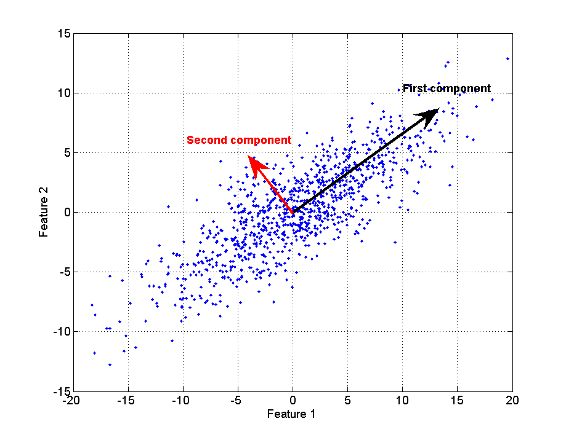
Figure ‎2-1: Principal components vectors of 2-dimensional gaussian scatter points.
For a d-dimensional space, a dimension reduction of the points is done the same way
by using only their projection values on the first m components where $m\text{<<}d$. The $m×d$ projection matrix P is used to project each feature vector on the principal component vectors. Its rows are the principal component vectors sorted in decreasing order of variance, and it is applied on each point by matrix multiplication:
$v'=\text{Pv}$ (2.1)
v' is the projected vector on the principal components space and only its m first values can be used instead of the original feature vector v. To achieve a good dimension reduction, m should not be chosen to be too small, since there is a risk of losing relevant information for the problem being solved. The assumption that the information relevance grows with its variance is not always true, under some circumstances the crucial information might be expressed by a small variability. For example in figure 2-1, it could be that the first component is induced by noise, while the second contains the relevant information. There is no formal recommendation for the value of m, it is generally found empirically, depending on the problem being solved and its applications. Another limitation of PCA when applied for classification or regression is that it doesn’t use the labeling information. All points are treated the same way in the calculation of the principal components. This characteristic makes PCA a non-supervised dimension reduction method.

Linear discriminant analysis
Like mentioned above, one of the PCA limitations is its disregard to the label information. Ideally, in a classification problem, the feature vectors should be represented in a space where the class discrimination is easy. This is the purpose of linear discriminant analysis (LDA), sometimes known as Fisher’s linear discriminant, after its inventor, Fisher [15]. The objective of LDA is to perform dimension reduction while preserving as much of the class discriminatory information as possible. The idea is to find a projection where points from the same class are projected very close to each other and, at the same time, the projected means are as farther apart as possible. Figure 2-2 shows a 2-class problem where the classes have a similar distribution but are centered at different regions.
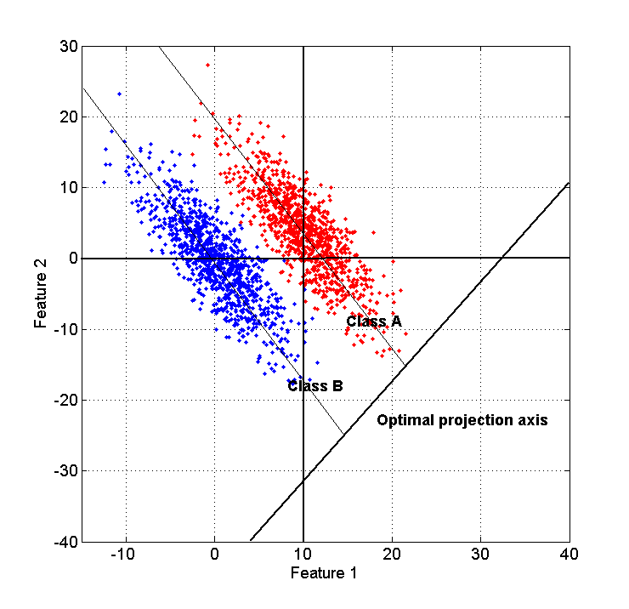
Figure ‎2-2: Optimal projection axis for a 2-classes separation problem. The distance between the class means is maximal while the within-class variance is minimal.

Using the data points with their label, the within-class scatter matrix $S_{W}$ and the between-class scatter matrix $S_{B}$ are calculated. Then, a projection matrix P is calculated to maximize the criterion function:
$δ=\frac{\left|P^{T}S_{B}P\right|}{\left|P^{T}S_{W}P\right|}$ (2.2)
It is shown in [15] that the maximum is achieved when P is the matrix whose columns are the eigenvectors corresponding to the largest eigenvalues of $S_{W}^{\text{-1}}S_{B}$. Because of the nature of the between-class scatter matrix, the LDA projection matrix of a C-classes problem will have at most C-1 components. As a result of that, the number of features after the mapping is at most C-1 which is generally very small and sometimes insufficient to achieve good classification accuracy. Another limitation of LDA is its assumption that all classes distribute normally with the same covariance [15].

Nuisance attributes projection
The nuisance attribute projection (NAP) is a technique introduced by Solomonoff and Campbell in [5] developed for the speaker recognition problem. It is applied on the feature vectors to eliminate the channel effect on the speech signal to obtain a more robust speaker detection system, insensitive to channel variability. In the speaker recognition task, it is the variability between speech sessions spoken by the same speaker under different channel conditions (cellular phone, landline phone, VOIP, etc…). Figures 2-3 and 2-4 illustrate the feature vectors distribution of different speakers before and after applying NAP projection on them respectively. Every speaker is represented by a different color, it can be seen that the inner-class variability is reduced after the NAP projection and allows a better separability. In the speaker recognition framework, the projection is applied on the GMM supervectors representing the speech sessions of different speakers. It is done by linear projection to a basis where the undesired variability is minimal. Experiments were conducted on the 2003 NIST extended data task evaluation with two different landline phone channels, carbon-button and electret. The experiment included equal error rate (EER) measurement of the detection system under different training and testing conditions. When using the same channel in the training and testing, NAP showed a small degradation in performance but when using different channel type the performance was improved.
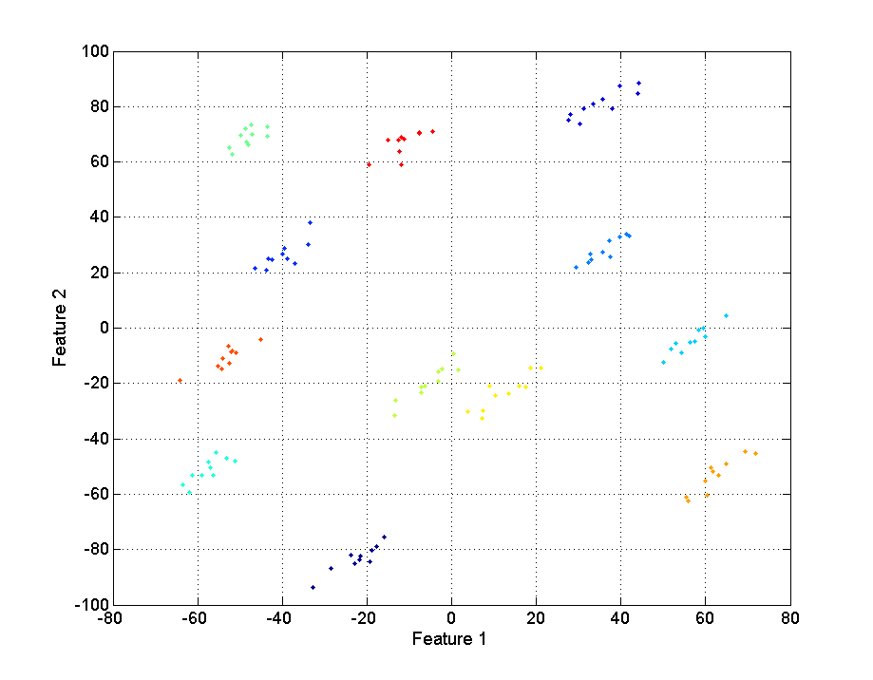
Figure ‎2-3: An illustrative example of speakers’ distribution, each color represents a different speaker before NAP projection.
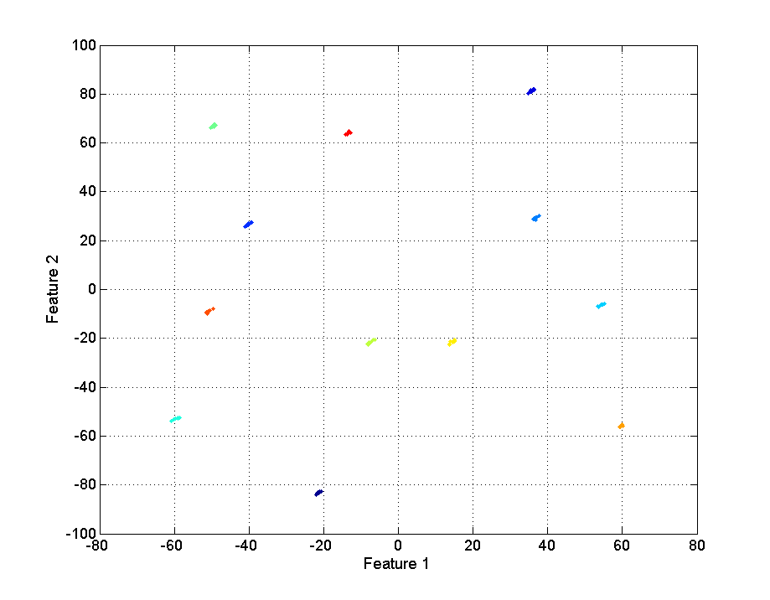
Figure ‎2-4: Distribution after NAP projection of the same speakers.
One of the drawbacks of using NAP might be the loss of crucial information when removing the relevant variability in data. Vogt [6] proposed a variant method called discriminant-NAP for speaker recognition whose purpose is to overcomes this problem. This method is based on LDA and consists to find a basis maximizing the ratio between the within-class and between-class scatter matrices. The coordinates of the greatest variance in this basis are used as the undesired directions (nuisance) to form the null-space in the NAP projection. Experiments using NIST SRE tasks demonstrated a modest improvement comparing to the original NAP method.

Anchor modeling
The anchor modeling technique was first introduced by Sturim et al. [19] for efficient speaker indexing when using a large speaker database. This method was applied on a GMM-UBM system where each speaker is modeled by a GMM trained from the UBM via MAP adaptation. When a speaker utterance is tested, its probability score is calculated against a small set of GMMs called the anchor models. The scores obtained are used to form a characteristics vector checked against other speakers’ characteristics vectors by Euclidian distance. Experiments using speech data from NIST-2000 showed an EER of 24.2 % when using 668 anchor models. This performance is far from the baseline GMM-UBM which is 7.7%, but the computational efficiency in terms of Gaussian computation is 1000 faster with an archive of 1 million speakers. An improvement by doing anchor model pruning increased the performance and achieved an EER of 21.1 %.
Yang et al. [20] Improved the anchor modeling technique by introducing a rank based metric for the characteristic vector verification. Instead of using measures like Euclidian distance that treats all scores similarly, this method gives a different degree of reliability to each anchor model. The assumption is that each speaker is characterized by the set of anchor models that give him a high score. Each characteristics vector is sorted in descending order and the sorting permutation indexes are used. Experiments conducted using the YOHO and SRMC databases showed a great performance improvement. Using rank based metric, an EER of 19.96 % was achieved while the baseline system using Euclidian distances achieved an EER of 33.25 %.
In the field of language identification, the anchor modeling was used by Aronowitz and Noor [12]. This method was incorporated to improve efficiency of a GMM supervector SVM based language identification system. A GMM model was trained every train and test session and used to form a corresponding GMM supervector. Using the GMM supervector characterizing a session and the GMM supervector characterizing an anchor model, the GMM probability of the session on that anchor model can be approximated. Using this approximation, the probability is calculated over all the anchor models, to form the session characteristic vector. An SVM model is trained in the characteristic vectors space, and speech sessions are labeled by the language spoken. Experiments were conducted using the NIST 2003 LRE database that includes 12 different basic languages. The testing time was improved by a factor of 4.8 comparing to the baseline anchor GMM system. An EER of 4.7 % was achieved, which is slightly better than the baseline system that achieved 4.8 %.

Age estimation system
Two age estimation approaches are introduced and implemented: Age-group classification that assigns an age-group to the speaker and age regression, which is applied to estimate the speaker’s precise age in years using a regression model. These systems are both designed to be gender dependent in order to eliminate the gender information. The system block diagram shown in figure 3-1 is the age-group classification system and in figure 3-2 is the precise age estimation system. It can be seen that in both systems the training part consists of two phases: A and B. In phase A, the universal background GMM model (UBM) called “world model” is trained over a large speech database where speakers are uniformly distributed over ages and genders. In phase B, a GMM model is created for each training session using MAP adaptation on the UBM model, and a supervector is formed based on the GMM model. These steps will be described in further details later. In the testing phase, a testing session is processed as a training sessions, to create a corresponding GMM supervector. The dimension reduction projection matrix is applied on it to create a reduced vector used as a feature vector for both the classification and regression SVM models.
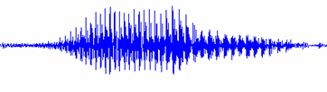
Feature extraction
GMM MAP adaptation
Supervector representation
Dimension reduction
SVM classifier
Class decision
Score normalization
Feature extraction
GMM UBM estimation
Feature extraction
UBM model
Dimension reduction matrix
SVM train
SVM models
GMM MAP adaptation
Dimension reduction matrix calculation
Supervector representation
Training Phase B
Speech database
Testing
Phase
Training Phase A
Dimension reduction
Scores distribution revaluation
Distribution parameters
Figure ‎3-5: Age-group classification system.

Feature extraction
GMM MAP adaptation
Supervector representation
Dimension reduction
SVM regression
Precise age estimation
Feature extraction
GMM UBM estimation
Feature extraction
UBM model
Dimension reduction matrix
SVM regression train
SVM regression
model
GMM MAP adaptation
Dimension reduction matrix calculation
Supervector representation
Training Phase B
Speech database
Testing
Phase
Training Phase A
Dimension reduction
Figure ‎3-6: Precise age regression system.

Feature extraction and dimension reduction
For the GMM means supervector framework, figures 3-3, 3-4 and 3-5 show the block diagram of the system. The GMM supervectors creation consists of several parts: first, like shown in figures 3-1 and 3-2, the universal background model (UBM) is trained over a large speech database, then a GMM MAP adaptation is performed for each speaker to obtain a speaker specific model based on which the GMM supervector is created and finally, the dimension reduction is applied.

Training the UBM
The UBM is a GMM model trained over mel-frequency cepstrum coefficients (MFCC) acoustic features, extracted from speech utterances, segmented from recorded speech sessions. A GMM model is defined by a set of parameters λ defining weights $w_{i}$, means $μ_{i}$and covariance matrices$Σ_{i}$ of M Gaussian components ($1≤i≤M$) that build together a probability function of a set of observations. At the training stage, EM (expectation-maximization) algorithm is performed to estimate the parameters of GMM. Gaussian components can be considered to model the underlying broad phonetic sounds that characterize a person’s voice. Since the GMM defines a distribution function, it is used for likelihood estimation of a new observation $o_{t}$, which is in our case the MFCC feature vector corresponding to the speech frame at time t.
The likelihood estimation formula of a single feature vector is:
$p(o_{t}|λ)=\sum_{i=1}^{M}{w_{i}p_{i}(o_{t})}$ (3.1)
where $p_{i}(o_{t})$ is the probability obtained by the $i^{\text{th}}$Gaussian calculated as follows:
$p_{i}(o_{t})=\frac{1}{(2π)^{D/2}\sqrt{\left|Σ_{i}\right|}}e^{−\frac{1}{2}(x−μ_{i})^{T}Σ_{i}^{{}^{−1}}(x−μ_{i})}$ (3.2)
where D is the feature vector dimension.
The training process is done by the EM iterative algorithm that involves two steps per iteration: the estimation and the maximization.
The estimation step consists to calculate the probability of membership to each component of all the training samples. The calculation is as follows:

$p(o_{t}|λ_{i})=\frac{w_{i}p_{i}(o_{t})}{\sum_{i=1}^{M}{w_{i}p_{i}(o_{t})}}$ (3.3)
Then in the maximization, the model parameters are updated. The component means as follows:
${\hat{μ}}_{i}=\frac{\sum_{t=1}^{n}{o_{t}p(o_{t}|λ_{i})}}{\sum_{t=1}^{n}{p(o_{t}|λ_{i})}}$ (3.4)
The covariances are updated as follows:
${\hat{σ}}_{i}^{2}=\frac{\sum_{t=1}^{n}{(o_{t}−{\hat{μ}}_{i})^{2}p(o_{t}|λ_{i})}}{\sum_{t=1}^{n}{p(o_{t}|λ_{i})}}$ (3.5)
And the weights:
${\hat{w}}_{i}=\frac{1}{n}\sum_{t=1}^{n}{p(o_{t}|λ_{i})}$ (3.6)
These steps are repeated until convergence or a maximum number of steps are performed. Figure 3-3 shows the system diagram of the UBM training system.

Diversified speech database
UBM training
Acoustic
features extraction
EM Training
UBM model

Figure ‎3-7: UBM model training.

The speech sessions used to train the UBM must be from speakers uniformly distributed over ages and genders. The UBM model is also called the “world model” since it represents a large and varied set of speakers.

Adaptation of the speaker’s model
After the model of UBM is constructed, MAP (maximum a posteriori) estimation is used to adapt the UBM model to represent the model of a specific speaker. The adaptation is done using the MFCC features extracted by the speaker session like shown in figure 3-4. The formulas are as follow:
${\bar{μ}}_{i}=\frac{\sum_{t=1}^{n}{p(o_{t}|λ_{i})}}{τ+\sum_{t=1}^{n}{p(o_{t}|λ_{i})}}{\hat{μ}}_{i}+\frac{τ}{τ+\sum_{t=1}^{n}{p(o_{t}|λ_{i})}}μ_{i}$ (3.7)

where τ is a weighting of the a priori knowledge to the adaptation speech data. The MAP adaptation is only made on the Gaussian means, leaving their weights and covariance matrix unchanged.

Building the supervector
Each GMM model is represented by GMM supervector v, formed by concatenating all the M Gaussians’ means:
$v=\left|\begin{matrix}μ_{1} \\ μ_{2} \\ \text{.}\text{.}\text{.} \\ μ_{M}\end{matrix}\right|$ (3.8)
Where $μ_{i}$ is the mean vector of the $i^{\text{th}}$ Gaussian. The training supervectors are formed using the MAP adapted GMM models. In the baseline system, the supervectors are used as feature vectors, but in our system we implement dimensionality reduction step used to reduce the dimension size of the feature vectors. For that, we use the supervectors to calculate the dimension reduction projection matrix. For each dimension reduction approach, the projection matrix calculation is different, but it always comes in form of a linear transformation matrix applied on the supervectors by matrix multiplication. The reduced vectors are used as feature vectors for the age-estimation.

UBM model
Dimension reduction matrix
Training feature vectors
Dimension reduction matrix estimation
Dimension reduction
GMM MAP adaptation
Supervector representation
Acoustic
features extraction
Speech database of the training
sessions
Training GMM supervectors
Figure ‎3-8: Feature extraction and processing of training sessions

The feature extraction of a given test session is shown in figure 3-5. The speech session is processed as the training sessions: a corresponding GMM model is trained, a GMM supervector is formed and the dimension reduction projection-matrix is applied on it to create a reduced testing feature vector. For the baseline system, the testing GMM-supervector is used as feature vector.

UBM model
Dimension reduction
GMM MAP adaptation
Supervector representation
Acoustic
features extraction
Speech session
Dimension reduction matrix
Testing feature vector
Figure ‎3-9: Feature extraction and processing of a candidate speech test session.

The following sections will describe in details the training and testing phases of the two studied systems: the age-group classifier and the precise age regressor.

Age estimation by classification.
Age estimation can be made by classification, like it is also done for speaker, language or gender identification problems. In our work, speakers are divided to 3 age-groups for every gender: Young people (Y), adults (A) and seniors (S). In order to isolate age information from the gender, the models are gender dependent. Using SVM models, this 3-class problem is handled in a one-vs.-all fashion: an SVM model is trained for each class, separating it from the two others. Experiments showed that classifying the adults group (A) from the rest is difficult and gives low performance, so we use only two binary classifiers: $C_{Y}$separating the group of Young people (Y) from all the rest (A and S) and $C_{S}$ separating the group of Seniors (S) from all the rest (Y and A). In the training of$C_{Y}$, young speakers (Y) were labeled as positive (1) and the rest were labeled as negative (-1). For $C_{S}$, senior speakers (S) were labeled as positive (1) and the rest as negative (-1). The training process is described in figure 3-6, it can be seen that using the feature vectors extracted by the feature extraction module. First, the vectors are divided to age-groups according to the label information, and the two SVM classifiers are trained. The SVM cross validation scores are evaluated on the training set using the N-fold cross validation technique and their distribution parameters are revaluated by Gaussianization. Section 5.2 explains in details how the SVM score is obtained with the SVM model parameters.

Cross-Validation scores distribution revaluation
SVM models training
Cross-Validation scores calculation
Vectors division to age-groups
Training feature vectors
SVM models
Scores distribution parameters
Figure ‎3-10: Training procedure of the Age-group classification system.

We assume that the cross validation scores have a similar distribution as the testing scores, so the SVM scores distribution obtained on a cross validation set for each age group is modeled. The distribution model serves to build a function that transforms the SVM scores obtained the classifiers to probability-of-membership values for each one of the three age-groups. Figure 3-7 shows the scores distribution obtained by classifiers $C_{Y}$ and $C_{S}$, every color represents a different age-group. An arrow shows the direction of growing probability-of-membership for each age-group: the farther the score-pair is in this direction, the more confident is the speaker membership to the class. It can be seen that scores from different groups are distributed differently in the scores space and can be modeled by a single bidimensional Gaussian probability distribution function (PDF). The multivariate Gaussian PDF function formula is:
$p_{g}(x)=\frac{1}{2π\sqrt{\left|Σ_{g}\right|}}e^{−\frac{1}{2}(x−μ_{g})^{T}Σ_{g}^{{}^{−1}}(x−μ_{g})},g∈\left\{Y,A,S\right\}$ (3.9)
Where x is the score vector $\left\langle x_{Y},x_{S}\right\rangle$ formed by the two scores obtained from classifiers $C_{Y}$ and $C_{S}$ respectively. $μ_{g}$and$Σ_{g}$are the mean vector and covariance matrix of the SVM scores corresponding to all speakers from group g.
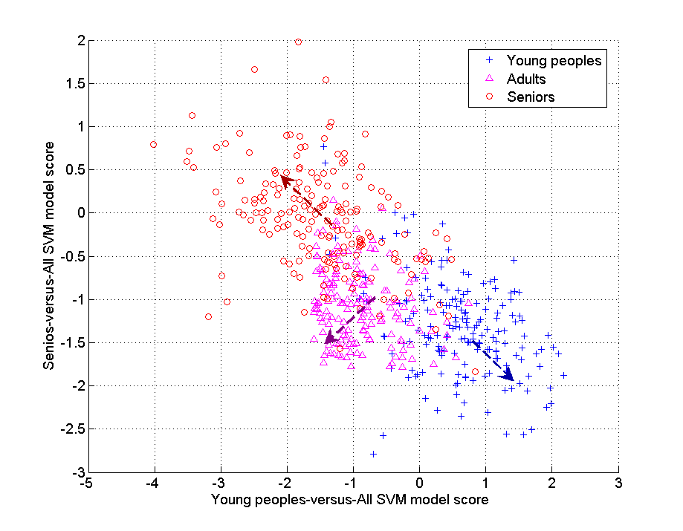
Figure ‎3-11: Bidimensional representation of cross validation scores obtained by the two SVM models for every speaker from each of the three age-groups.
The cumulative distribution function of $p_{g}$ (3.9) is a bivariate gaussian cumulative function approximated by an algorithm proposed by Genz [16] and this is the normalization applied on the SVM scores:
$Φ_{g}(x)=\int{p_{g}(z)dz}$ (3.10)
Now, every testing score-pair vector $x_{t}$ obtained from the two classifiers is mapped to three values: $Φ_{Y}(x_{t})$, $Φ_{A}(x_{t})$ and $Φ_{S}(x_{t})$ that represent the membership probability estimation to each one of the age groups Y, A and S respectively. Figure 3-8 shows the classifier testing process on a speech session. The feature vector extracted by the feature extraction system is used, and its score evaluated on the two SVM models. The score-pair obtained is transformed to probability of memberships values $Φ_{Y}(x_{t})$, $Φ_{A}(x_{t})$ and $Φ_{S}(x_{t})$. Age-group decision is made by choosing the age-group with the highest probability of membership estimation. This normalization method was found to give a very well balanced confusion matrix with no bias in favor to anyone of the age groups.

Scores distribution parameters
Testing feature vector
Class decision
SVM models testing
Scores normalization
SVM models
Speaker’s age group
Figure ‎3-12: Testing procedure of the Age-group classification system.

Age estimation by regression
Another approach to do age estimation is by modeling the precise speaker age. The representation of every speaker by his/her age-group is a quantization that doesn’t take into account the complete age information. Speakers of age close to the age-group boundaries tend to be more often misclassified since they share more properties with the speakers from the adjacent group. By modeling the precise speaker age, the complete age information is taken into account and speakers from different age (in years) are handled differently. A common way to estimate a continuous label like age is by doing a regression to find the continuous function that maps each speaker’s feature vector to its corresponding age. In our case the GMM supervector framework is used and the feature vectors are the reduced supervectors. The label is the speaker’s age provided as integer numbers in years, but treated like real values since regressive models are designed to model real valued labels. A support vectors regression (SVR) [17] model is trained on the feature vectors like shown in figure 3-9.
UBM model
Dimension reduction matrix
Training feature vectors
Dimension reduction matrix calculation
Dimension reduction
GMM MAP adaptation
Supervector representation
Acoustic
features extraction
Speech database
Training GMM supervectors
SVM model training
SVM regression model

Figure ‎3-13: Training procedure of the age regression system.

The SVR parameters, like the error cost factor C and the minimal error margin ε are calibrated using the N-fold cross validation technique on the training set. For the testing phase as shown in figure 3-10, the testing feature vector is evaluated by the SVM model that outputs the exact age estimation.
UBM model
Dimension reduction
GMM MAP adaptation
Supervector representation
Acoustic
features extraction
Speech session
Dimension reduction matrix
Testing feature vector
SVM regression model
SVM regression model testing
Speaker’s age

Figure ‎3-14: Testing procedure of the age regression system.

Dimension reduction approaches
In this section, we describe the four dimension reduction methods mentioned in section 1. They were implemented, evaluated and compared to a baseline system where the GMM supervectors are used directly as feature vectors for SVM with no dimension reduction.

Principle components analysis
PCA [14] is an orthogonal linear transformation that projects a set of vectors to a new basis whose components are linearly uncorrelated and arranged in a decreasing order of variance. This method assumes that most of the relevant information is found in the first coordinates of the projected space, since they contain most of the variance. A dimension reduction is then made by using only the first m coordinates of the projected vectors such that $m\text{<<}d$ and d is the original feature vectors dimension. The PCA projection matrix columns are the eigenvectors of the feature vectors correlation matrix. In the age estimation systems the PCA is calculated based on the $d×n$matrix A, whose columns are the n training supervectors. Since the supervectors dimension generally exceeds the number of training points (d > n), the correlation matrix of A is singular. The eigenvectors must then be extracted using singular vector decomposition (SVD) of A. This process results in a rectangular matrix used as the projection matrix whose columns are the principal components vectors.

Supervised PCA
SPCA is a PCA variant where the feature vectors are preprocessed before applying PCA on them. The preprocessing consists of screening out coordinates having the lowest correlation with labels. First, the correlation vector c between the training supervectors and the labels is calculated:
$c=\hat{A}\hat{y}$ (4.1)
where$\hat{A}$is the normalized input training supervectors matrix and $\hat{y}$is the normalized label vector, both of them are normalized by their mean value and standard-deviation. The vector c contains the correlation coefficient between each coordinate of the feature vectors and the labels. This method is generally used in regression problems [18] where the label is continuous; we can then apply it in the age regression system since age is a continuous variable. In the age-classification system, it is applied the same way, using the exact age label for the filtering. Next, we filter out coordinates having a correlation value below a predefined threshold τ and apply a standard PCA projection on the reduced vectors.

Weighted pairwise PCA
In PCA we achieve a dimension reduction that preserves most of the vectors variance without taking in account the class labels. There is no guarantee that the directions of maximum variance will contain good features for discrimination. We propose a technique that permits to shape the features variability at the projected space using the label information. The NAP projection framework proposed in [5] was found useful to eliminate inter-session speaker variability for speaker verification. The motivation of applying this technique is its ability to eliminate the unwanted variability common to speakers of the same age. Here we extend this framework to reduce the supervectors dimension while preserving most of the variability needed to discriminate speakers by age groups.

Projection matrix
We create an $d×m$ linear projection matrix P that projects the d dimensional supervectors to a subspace of dimension $m\text{<<}d$. P is chosen to maximize the pairwise variability criterion:
$δ=\sum_{i,j=1}^{n}{w_{i,j}{\left\|{\text{Px}}_{i}−{\text{Px}}_{j}\right\|}^{2}}$ (4.2)
Where W is the symmetric weight matrix containing weight values for all the vector pairs: $(x_{i},x_{j}),i,j=1,2,\text{.}\text{.}\text{.},n$. This formula is actually a weighted sum of the pairwise distances between every vector-pair $(x_{i},x_{j})$ in the projected space, defined by the projection matrix P. The matrix W contains the values corresponding to the weighting of every vector pair within the criterion. This framework allows us to manage the variability in the projected space according to the training feature vectors and their labels. We will use this capability to mold the desired variability in the projected space. What we need is that the distance between feature vectors corresponding to speakers of different age will be bigger than the distance between speakers of the same age. For that use, we will build the weight matrix like described in the next paragraph and find the projection matrix P that will maximize the criterion. According to [5], the variability criterion δ is maximized by choosing P whose columns are the m eigenvectors with the largest eigenvalues of matrix S:
$S=\text{AZ}(W)A^{t}$ (4.3)
A is the matrix whose columns are the training supervectors, Z(W)=diag(W1)-W, where diag(x) is the matrix whose diagonal is x, and 1 is the vector of all ones. The supervectors dimension is generally higher than the number of training sessions, making the matrix S is singular. However, the matrix S can be decomposed to $S={\text{VV}}^{t}$ where $V=\text{AZ}(W)$, so the eigenvectors of S can be determined by singular value decomposition (SVD) of V.

Weights matrix calculation
For the regression problem the weight matrix W is built as follows:
$w_{i,j}=\left|a_{i}−a_{j}\right|$ (4.4)
where$a_{i}$is the $i^{\text{th}}$ speaker age. Using this formula, the weight we get is the absolute age difference between speakers. As a result of this, the distance between two feature vectors in the projected space will grow with the age difference between their two correspondent speakers. Inversely, the distance between vectors corresponding to speakers of the same age will be minimized. By these properties, the features variability common to all speakers from the same age will be reduced on the favor of the variability common to speakers from different ages.
For the classification problem, we first introduce the preprocessing algebraic logistic function:
$ψ_{θ,β}(x)=\frac{x−θ}{\sqrt{β+(x−θ)^{2}}}$ (4.5)
where θ is the center of the logistic function and β is its width factor. Figure 4-1 shows the logistic function (7) applied with parameter θ equals to 25 and 55 respectively on the range of 0 till 100. Applied on age values, the logistic function is monotonically increasing and emphasizes the age-group membership: Its value applied on ages below and above θ is much more different than if applied on ages from the same side.
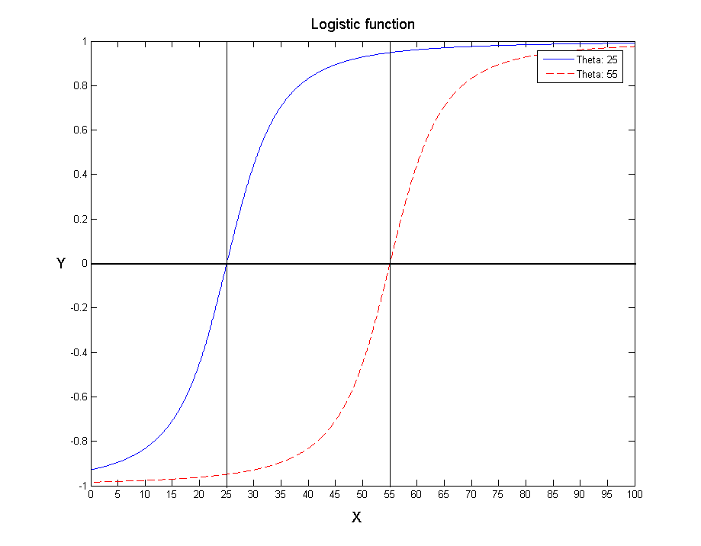
Figure ‎4-15: Logistic preprocessing function $ψ_{θ,β}$ using β=100 and θ=25 in Blue, θ=55 in Red
The value of β is chosen empirically and must be large enough to emphasize the difference between speakers from different age-groups and small enough to let the real age difference to have an influence. The weight matrix is built accordingly using the following formula:
$w_{i,j}=\left|ψ_{A,β}(a_{i})−ψ_{A,β}(a_{j})\right|$ (4.6)
where$a_{i}$is the $i^{\text{th}}$ speaker age. This weights matrix is applied in (4) to obtain the projection matrix P. In our classification system, we use only two binary classifiers: $C_{Y}$ separating the group of young peoples from the rest and $C_{S}$ separating the group of seniors from the rest, both of them are separate between speakers below and above a certain separation age. A projection matrix will be built for each one of the classifiers using the preprocessing logistic function (7) with the parameter θ equals to the classifier’s separation age. Within the projected space, the features within-class variability will be minimized on the favor of the between-class variability to ease on the model’s separation ability.

Anchor modeling
Anchor modeling is a technique generally used for speaker verification [10] to project a given session into a low-dimensional scores space. This technique uses anchor models trained on a predefined set of speech sessions. In our framework these models are obtained by MAP adaptation of the UBM. The anchor models representation of a candidate session x is by the log-likelihood scores it obtained by the anchor models.

Projection matrix
It was shown in [12] that using normalized GMM supervector, the log-likelihood values obtained by the anchor models are approximated by:
$s(x)≈{\hat{Λ}}^{t}{\hat{v}}_{x}$ (4.7)
where $\hat{Λ}$ is the normalized anchors supermatrix whose columns are all the normalized supervectors of the anchor models and ${\hat{v}}_{x}$ is the normalized GMM supervector of session x. The supervector normalization is applied on the concatenated Gaussian means in (3.8), by the formula:
${\hat{μ}}_{i}=μ_{i}\sqrt{{w_{i}}/{Σ_{i}}}$ (4.8)
where $μ_{i},w_{i}$and$Σ_{i}$are the mean vector, weight and covariance matrix of the $i^{\text{th}}$ Gaussian respectively.

Anchor-supervectors selection
The anchor-supervectors need to be diversified and represent speakers from all class labels to ensure minimal information loss in the projected space. Moreover, projecting using adjacent anchor-supervectors in (4.7) gives highly correlated values, which leads to redundancy in the features. To avoid that, we use a selection method such that the anchor-supervectors are chosen to be distant from each other, considering them as points in a high-dimensional space. Finding a subset of the most distant points in a given set is an NP-complete problem. However, approximation randomized algorithms giving good results can be used instead: The close impostor clustering (CIC), an iterative algorithm proposed by Zigel and Cohen [21] was applied to select distant cohort models, needed for score normalization in speaker verification. A similar selection method is applied here by running a K-means clustering on the candidate supervectors and selecting one anchor from each cluster. Note that the normalization in (4.8). makes the log-likelihood approximation in (4.7) to be an upper-bound to the KL distance between GMM models. The KL distance between two models is upper-bounded as follows [24]:
$K(Φ_{x},Φ_{y})≤\sum_{i=1}^{g}{(μ_{i}^{x}\sqrt{{w_{i}}/{Σ_{i}}})^{t}⋅(μ_{i}^{y}\sqrt{{w_{i}}/{Σ_{i}}})={\hat{v}}_{x}^{t}⋅{\hat{v}}_{y}}$ (4.9)
where $Φ_{x}$ and $Φ_{y}$ are the MAP-adapted GMM models having the same weight values and covariance matrices, but different means vectors: $μ_{i}^{x}$ and $μ_{i}^{y}$. ${\hat{v}}_{x}$ and ${\hat{v}}_{y}$ are the normalized GMM supervectors of $Φ_{x}$ and $Φ_{y}$ respectively using the formula in (4.8). The KL distance approximation is then used as a distance measure for the K-means clustering. From each resulting cluster, the supervector closest to the cluster’s mean is chosen. By the nature of clustering, close vectors will be grouped within the same cluster, so the chosen anchor-supervectors will be distant and will span efficiently the supervectors’ space.

SVM algorithms complexity
SVM was first introduced in 1992 [22] as an optimal margin classifier training algorithm used in statistics and learning theory. It quickly became popular because of its performance on classification tasks and its ease of use comparing to neural-networks. The particularity of the SVM classifier is that it seeks to find a decision boundary to be as far away from the data of both classes. This property reduces the risk of the misclassification on the testing set by minimizing the Vapnik-Chervonenkis (VC) dimension of the classifier. The VC dimension is a measure introduced by Vladimir Vapnik and Alexey Chervonenkis, that defines the flexibility of a classifier by the cardinality of the largest set of points that the algorithm can shatter. Support vector machine can be applied not only to classification problems but also to the case of regression. A version of SVM for regression was proposed in 1996 by Vladimir Vapnik, Harris Drucker, Chris Burges, Linda Kaufman and Alex Smola[23]. This method is called support vector regression (SVR).

SVM training
The SVM training process for both the classification and regression tasks involves solving a linearly constrained convex quadratic program. This problem can be expressed in matrix notation like a standard quadratic optimization problem:
Maximize
$L(α)=−0\text{.}5α^{T}\text{Hα}+f^{T}α$ (5.1a)
subject to
$s^{T}α=0,$ (5.1b)
$0≤α≤C$ (5.1c)
where $(α)_{i}=α_{i}$are the free parameters whose values are to be found. H denotes the Hessian matrix, its size and values depend on the type of problem (classification or regression) and the training data. f and s are constant vectors with values depending on the problem’s type and training data. C is an error penalty parameter chosen by the user to control the trade-off between the model’s empirical error and its structural risk. Several iterative training algorithms were proposed [25][26] to solve the quadratic optimization involved in the SVM training, but their complexity depends on the nature of data and the resulting number of support vectors $N_{S}$. Algorithms using heuristic decomposition methods were developed to allow dealing with large datasets within a reasonable storage and computation time. Using decomposition, only portions of the training data are handled at a given time, popular approaches are the chunking method [22] proposed by Vapnik and the sequential minimal optimization (SMO) proposed by Platt [27]. The latter restricts to solve only two $α$elements per iteration, breaking the problem it to a sequence of two-variables sub-problems solved analytically. SMO was the basis to many implementations [28],[29], its complexity is approximated to be $O(l^{3}d)$, where l is the number of training vectors and d their dimension. Clearly, the training complexity grows linearly with respect to the training vectors dimension and its cost can be significant for a large number of training vectors l.

SVM testing
The SVM score evaluation of a d dimensional feature vector x consists to calculate the weighted sum of the kernel function k(x,z) calculated over all the$N_{S}$support vectors. For the SVM classification (See appendix A), the score calculation is:
$f(x)=\sum_{i=1}^{n}{α_{i}γ_{i}k(x,z_{i})+b}$ (5.2)
For SVM regression, the score calculation is: (5.3)
where f is the test score function,$y_{i}$are the target values, $α_{i}$ and $α_{i}^{}$ the model parameters and $z_{i}$ the support vectors. These formulae show that the complexity depends on the number of support vectors and the kernel function calculation. The kernel function depends on the chosen kernel type, but its complexity is generally$O(d)$. For the linear kernel case, the kernel function calculation is a dot product and it is possible to change the whole formula to require only one single dot product:
$f(x)=x⋅\left(\sum_{i=1}^{n}{α_{i}γ_{i}z_{i}}\right)+b$ (5.4)
The extension to the regression case is trivial. The overall testing complexity is then only$O(d)$. However, when using complex non-linear kernels a better generalization performance is achieved for both the regression and classification tasks. For example, using the Gaussian-RBF kernel the formula is:
$k(x,y)=e^{{−{\left\|x−y\right\|}^{2}}/2σ^{2}}$ (5.5)
where $σ$ is a constant parameter defining the Gaussian width, chosen by the user. This function involves a distance calculation between two vectors and must be calculated over all the resulting support vectors. The complexity of the test score function calculation f is in this case$O(\text{nd})$, which is similar for the polynomial and hyperbolic kernels. As it can be seen, the computation is very sensitive to the vectors dimension d.

Experimental Setup and Results

Database
Speech data used to train the UBM model was taken from LDC’s Switchboard corpus annotated with age and gender labels. Six minutes long sessions from 2430 speaker were taken summing up to around 50 hours of speech. For the training and testing sessions, LDC’s Fisher corpus was used. This database consists of 11699 spontaneous phone conversations lasting 10 minutes. 12000 different speakers are recorded, ~5000 males and ~7000 females with age ranging from 15 till 85 years old.

Classification database
For the age-group classification task, groups were defined as follows:

- Young people: 18-25 years (Y)
- Adults: 26-54 years (A)
- Seniors: 55-80 years (S)

Training and testing sets were selected as shown in Table ‎6-1. The sets of senior speakers are smaller than the others, especially in males because the Fisher database contains relatively few senior speakers.
Table ‎6-1. Session sets (number of sessions).
Gender | Age group | Training-set | Testing-set
Female | Y | 1250 | 1251
Female | A | 1395 | 1395
Female | S | 764 | 763
Female | Total | 3409 | 3409
Male | Y | 1255 | 1255
Male | A | 1395 | 1395
Male | S | 461 | 461
Male | Total | 3111 | 3111

Regression database
For the regression task, the speakers were chosen to uniformly span all ages. Table ‎6-2 and Table ‎6-3 show the age distribution of speakers used to build the training and testing sets in a resolution of 10 years. As it can be seen, there are fewer senior speakers here too, but the distribution is kept uniform at least from the age of 20 till 60.

Table ‎6-2. Speakers age distribution in training and testing set for female speakers.
Age range | Training-set | Testing-set
10-20 | 130 | 130
21-30 | 500 | 500
31-40 | 500 | 500
41-50 | 500 | 500
51-60 | 500 | 500
61-70 | 290 | 290
71-80 | 50 | 50
Total | 2470 | 2470

Table ‎6-3. Speakers age distribution in training and testing set for male speakers.
Age range | Training-set | Testing-set
10-20 | 170 | 170
21-30 | 500 | 500
31-40 | 500 | 500
41-50 | 500 | 500
51-60 | 500 | 500
61-70 | 190 | 190
71-80 | 40 | 40
Total | 2400 | 2400

Experimental setup
The acoustic features used are MFCC with 12 coefficients + C0 and their first derivatives forming a 26 dimension acoustic feature vector. The UBM is trained to 512 Gaussians, so the GMM supervectors dimension is 13312 $(\text{26}×\text{512})$. The dimension reduction approaches were applied at different reduction levels on the supervectors and the performance were measured. The WPPCA method was applied in the classification tasks using the weight matrix from (8). The preprocessing function ψ parameters θ was set to 25 for Young-versus-all classifier ($C_{Y}$) and to 55 for Seniors-versus-all classifier ($C_{S}$). For both classifiers, the parameter β was set to 100. For the SPCA method, the threshold parameter τ was chosen to filter out 20% of the original supervector dimensions. When training the SVM models, the error penalty parameter C was optimized empirically using n-fold cross validation evaluation for every model. For models trained with the Gaussian RBF kernel, the $σ$ parameter defining the width of the Gaussian function was set to where Σ is the training feature vectors covariance matrix. This value was found optimal on empirical experiments.
The system was written in the Python language [30] using Scipy [31] scientific library for the algebraic calculations. The acoustic features extraction and the GMM models training was done with the HTK [32] toolset. The SVM models training and testing was done with the LIBSVM [28] tool.

Classification results

Performance evaluation
The performance of the two binary SVM classifiers is measured by their equal error rate (EER). To assess the effectiveness of each one of the dimensionality reduction methods, the EER is measured at every reduction level ranging from 100 till 1000 dimensions. The four methods results are compared with the baseline system performance using the full GMM supervectors. Figure ‎6-16 and Figure ‎6-17 show the EER performance on female speakers obtained with the two classifiers $C_{S}$ and $C_{Y}$ using linear kernel while Figure ‎6-18 and Figure ‎6-19 show these results for the male speakers. It can be seen that WPPCA performed the best in each configuration using a relatively low feature vector dimension. Comparing to the baseline system using a vector dimension of 13312, this performance is in average 3.5% better for female speakers and 5% better for males. The second best performer is the anchor-model approach with 2.5% better for female speakers 3% better for males.
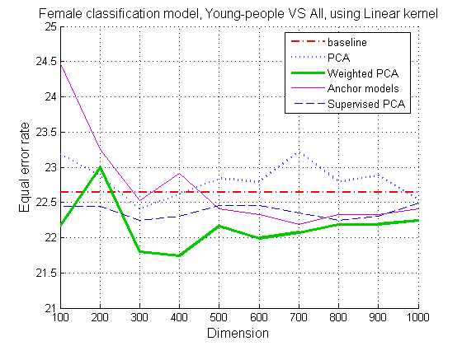
Figure ‎6-16 EER obtained on female speakers vs. target dimension on $C_{Y}$ classifier
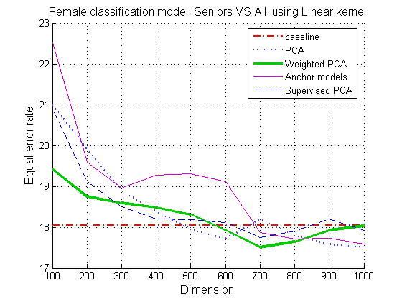
Figure ‎6-17 EER obtained on female speakers vs. target dimension on $C_{S}$ classifier

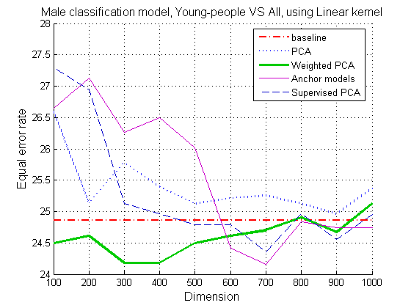
Figure ‎6-18 EER obtained on male speakers vs. target dimension on $C_{Y}$ classifier
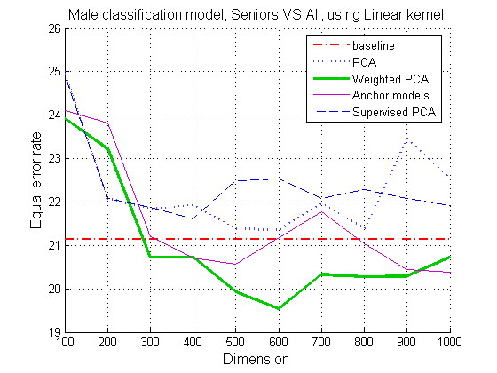
Figure ‎6-19 EER obtained on male speakers vs. target dimension on $C_{S}$ classifier
Figure ‎6-20 and Figure ‎6-21 show the EER performance of the same classifiers using the RBF kernel on female speakers while Figure ‎6-22 and Figure ‎6-23 show these results for the male speakers. Comparing to the linear kernel results the average performance is better for all methods including the baseline system. Table ‎6-4 and Table ‎6-5 compare the average EER obtained using each method with every kernel. Again WPPCA achieved the best results, 6.5% better than the baseline for female speakers and 6.2% better for males. The second best performer is the anchor-model approach with a slight improvement of 1.5% for female speakers and 1.2% for males.

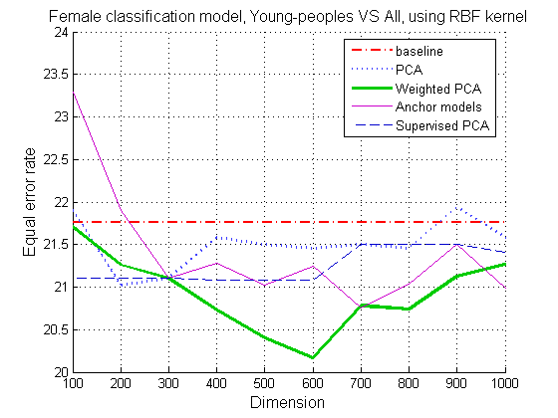
Figure ‎6-20 EER obtained on female speakers vs. target dimension on $C_{Y}$ classifier (Young-peoples-vs-All).
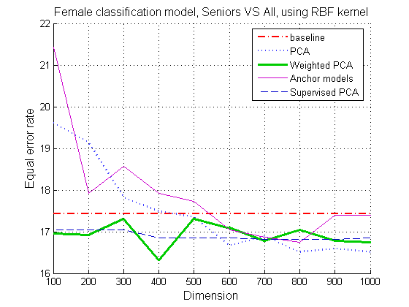
Figure ‎6-21 EER obtained on female speakers vs. target dimension on $C_{S}$ classifier (Seniors-vs-All).
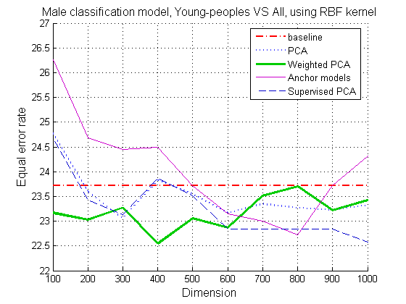
Figure ‎6-22 EER obtained on male speakers vs. target dimension on $C_{Y}$ classifier (Young-peoples-vs-All).
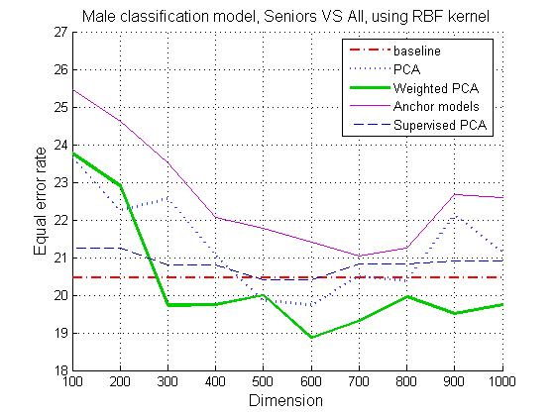
Figure ‎6-23 EER obtained on male speakers vs. target dimension on $C_{S}$ classifier (Seniors-vs-All).

Table ‎6-4 Best EER obtained with each dimension reduction approach on female speakers.

Method | Classifier | Linear kernel |  | RBF kernel
Method | Classifier | Best EER | Dim | Best EER | Dim
Baseline | $$C_{Y}$$ | 22.64 % | 13312 | 21.76 % | 13312
Baseline | $$C_{S}$$ | 18.05 % | 13312 | 17.43 % | 13312
PCA | $$C_{Y}$$ | 22.39 % | 300 | 21.02 % | 200
PCA | $$C_{S}$$ | 17.50 % | 1000 | 16.51 % | 800
WPPCA | $$C_{Y}$$ | 21.73 % | 400 | 20.16 % | 600
WPPCA | $$C_{S}$$ | 17.50 % | 700 | 16.30 % | 400
Anchor modeling | $$C_{Y}$$ | 22.18 % | 700 | 20.76 % | 700
Anchor modeling | $$C_{S}$$ | 17.58 % | 1000 | 16.74 % | 800
SPCA | $$C_{Y}$$ | 22.25 % | 300 | 21.08 % | 400
SPCA | $$C_{S}$$ | 17.74 % | 700 | 16.81 % | 700
Average | $$C_{Y}$$ | 22.24 % | - | 20.95 % | -
Average | $$C_{S}$$ | 17.67 % | - | 16.76 % | -

Table ‎6-5 Best EER obtained with each dimension reduction approach on male speakers.

Method | Classifier | Linear kernel |  | RBF kernel
Method | Classifier | Best EER | Dim | Best EER | Dim
Baseline | $$C_{Y}$$ | 24.86 % | 13312 | 23.72 % | 13312
Baseline | $$C_{S}$$ | 21.14 % | 13312 | 20.45 % | 13312
PCA | $$C_{Y}$$ | 24.96 % | 900 | 23.05 % | 300
PCA | $$C_{S}$$ | 21.36 % | 600 | 19.73 % | 600
WPPCA | $$C_{Y}$$ | 24.18 % | 300 | 22.54 % | 400
WPPCA | $$C_{S}$$ | 19.53 % | 600 | 18.86 % | 600
Anchor modeling | $$C_{Y}$$ | 24.15 % | 700 | 22.72 % | 800
Anchor modeling | $$C_{S}$$ | 20.39 % | 1000 | 21.04 % | 700
SPCA | $$C_{Y}$$ | 24.35 % | 700 | 22.57 % | 1000
SPCA | $$C_{S}$$ | 20.60 % | 400 | 20.41 % | 500
Average | $$C_{Y}$$ | 24.50 % | - | 22.92 % | -
Average | $$C_{S}$$ | 20.80 % | - | 20.10 % | -

For each method, the two classifiers $C_{Y}$ and $C_{S}$ were combined for the age-group classification system described in section 3. The performance was evaluated based on the confusion matrix obtained on the testing set. Figures 6-9, 6-10, 6-11 and 6-12 compare the precision values of the age-group classification system using each dimensionality reduction method and the baseline system. Figures 6-8 and 6-9 show the performance of the system using the linear kernel while figures 6-10 and 6-11 are of the system using the Gaussian RBF kernel. The best accuracy is obtained using the WPPCA method which is 1.3% better than the baseline when using the linear kernel and 1.5% better using Gaussian RBF kernel. Surprisingly, the age-group classification model performance isn’t improved as much as the SVM binary classifiers performance measured separately. Table ‎6-6 and Table ‎6-7 show the confusion matrices of the classification systems using the RBF kernel and the WPPCA approach. The first one, trained on female speakers uses feature vectors of dimension 300; the second one, trained on male speakers uses feature vectors of dimension 600. It can be seen that the confusion matrices are well balanced.
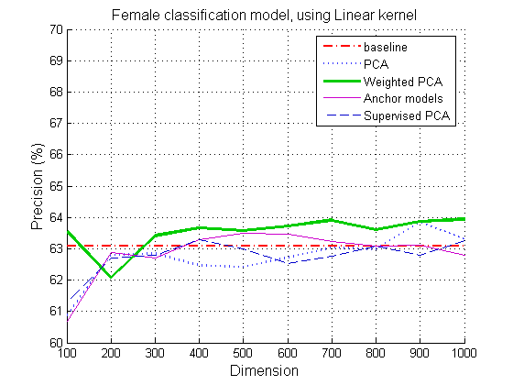
Figure ‎6-24 Age-group classification precision vs. target dimension on female speakers using Linear kernel.
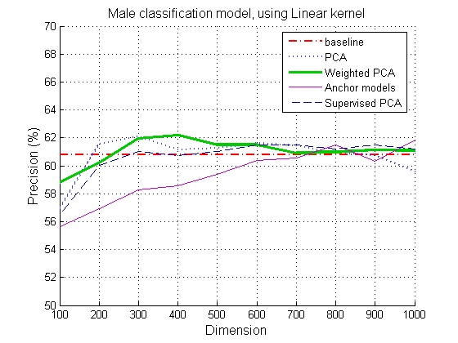
Figure ‎6-25: Age-group classification precision vs. target dimension on male speakers using Linear kernel.
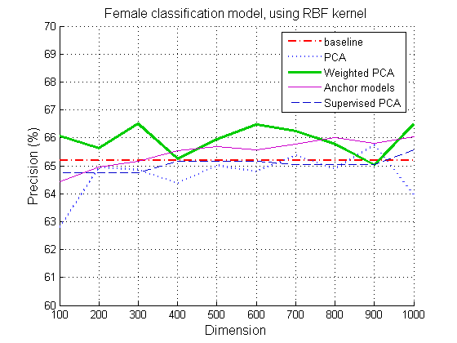
Figure ‎6-26: Age-group classification precision vs. target dimension on female speakers using RBF kernel.
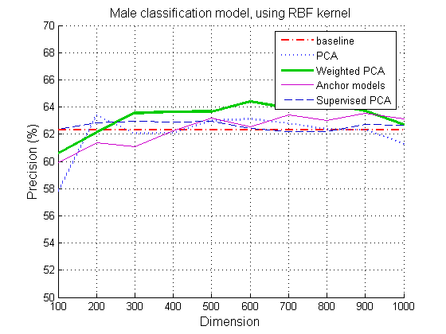
Figure ‎6-27: Age-group classification precision vs. target dimension on male speakers using RBF kernel.
Table ‎6-6: Classification system confusion matrix using the WPPCA approach on female speakers, RBF kernel and feature vectors of dimension 300. Rows: actual age, Columns: classified age.
(Precision: 66.5%, Recall: 68.8%)
Actual \ Classified | Y | A | S
Y | 834 | 392 | 25
A | 264 | 908 | 223
S | 15 | 231 | 517

Table ‎6-7: Classification system confusion matrix using the WPPCA approach on male speakers, RBF kernel and feature vectors of dimension 600. Rows: actual age, Columns: classified age.
(Precision: 64.4%, Recall: 66.8%)
Actual \ Classified | Y | A | S
Y | 829 | 403 | 23
A | 272 | 878 | 245
S | 14 | 151 | 296

Speed measurements
The supervectors dimension reduction has a great impact on the testing time. Figure ‎6-28 shows the relation between the feature vectors dimension and the SVM model training time. In the baseline system using the GMM supervectors of dimension 13312 as feature vectors, the SVM training time is 597 seconds. It can be seen that this time is 50 to 100 times shorter when using reduced feature vectors. Figure ‎6-29 shows the relation between the feature vectors dimension and the testing process time. This process includes the dimension reduction of the GMM supervector and the SVM testing step. The dimension reduction process is the same for all the tested approaches and consists of a multiplication between the GMM supervector and the projection matrix. Using the full GMM supervectors, the SVM testing time is 468 milliseconds which is much higher than the whole testing process using dimension reduction. At target dimension of 600 (which best performed on average), the testing time drops by ~76% from 468 to 110 milliseconds. The main reason of this time reduction is the RBF kernel evaluation complexity, which is highly sensitive to the vectors dimension. Another reason of that is the reduced number of support vectors in the SVM model. Interestingly, when training the SVM classifiers with the reduced vectors, the number of support vectors is also decreased. The SVM testing grows with the number of support vectors (see formula 5.2). Figure ‎6-30, Figure ‎6-31, Figure ‎6-32 and Figure ‎6-33 show the resulting number of support vectors in the model for each dimension. It can be seen that the number of support vectors is reduced when the feature vectors dimension is lower. Fewer support vectors lead to a lower model’s structural risk (VC dimension) which is favorable to the model generalization performance.
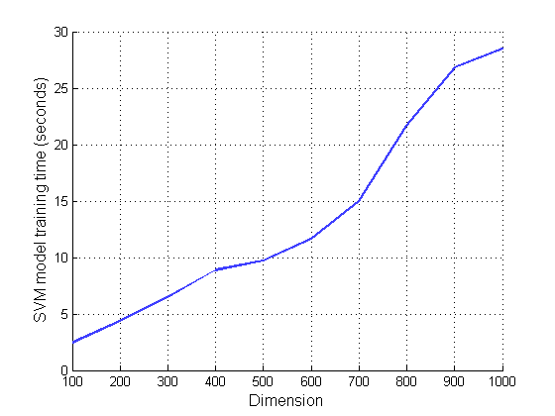
Figure ‎6-28: Average SVM training time (in seconds) versus feature vectors dimension using RBF kernel. On the baseline system, with feature vector dimension of 13312 the training time is 597 seconds. (Running on an Intel™ Pentium IV).
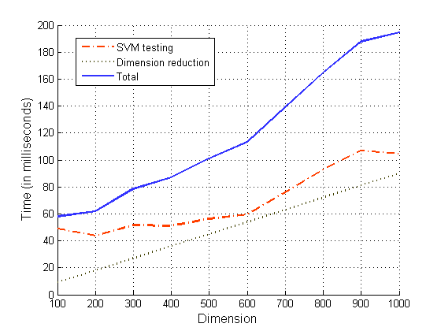
Figure ‎6-29: Average testing time (in milliseconds) per vectors dimension using RBF kernel. On the baseline system, with feature vector dimension of 13312 the SVM testing time is 468 milliseconds. (Running on an Intel™ Pentium IV).
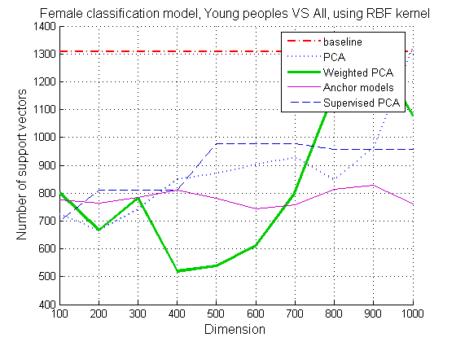
Figure ‎6-30: Number of support vectors vs. target dimension on $C_{Y}$ classifier trained using RBF

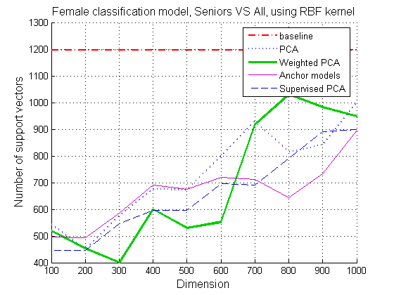
Figure ‎6-31: Number of support vectors vs. target dimension on $C_{S}$ classifier trained using RBF kernel on female speakers.
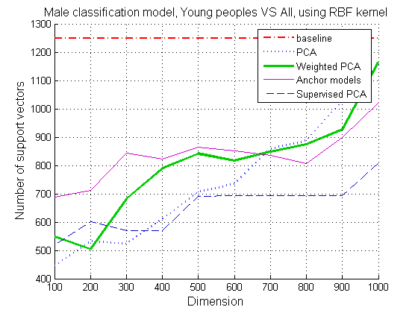
Figure ‎6-32: Number of support vectors vs. target dimension on $C_{Y}$ classifier trained using RBF kernel on male speakers.

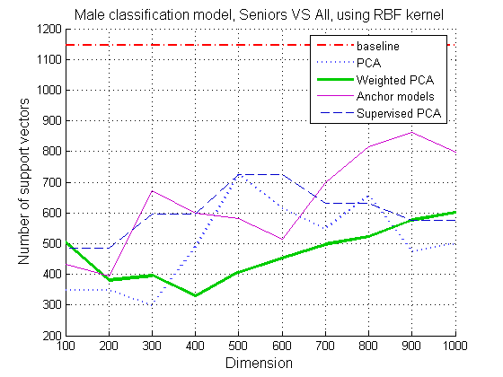
Figure ‎6-33: Number of support vectors vs. target dimension on $C_{S}$ classifier trained on male speakers.

Regression results

Performance evaluation
The model’s correctness is evaluated by calculating the absolute mean error in years. This evaluation criterion is chosen since it is also the criterion minimized by SVR training. Figure ‎6-34 and Figure ‎6-35 show the performance of the regression model for each dimension reduction approach using linear kernel while Figure ‎6-36 and Figure ‎6-37 show the results using an RBF kernel. It can be seen WPPCA method performed the best also in the regression task, the absolute mean error is improved by 3.4 % for female speakers and 7.6 % for male speakers using linear kernel. Like in the classification task, using RBF kernel the average performance is improved for all the methods including the baseline system. WPPCA method showed an improvement of 8 % for female speakers and 9.6 % for male speakers. Figure ‎6-38 and Figure ‎6-39 show the predicted versus actual age of the best regression models using the WPPCA approach for female and male speakers respectively. The anchor modeling approach didn’t perform as well as WPPCA, but it was the second best performer when using a linear kernel. All the tested approaches performed better than the baseline system.

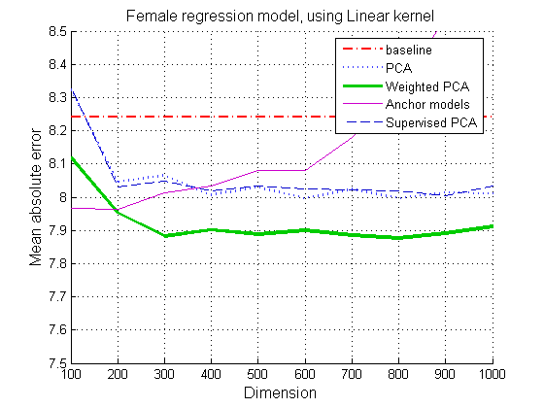
Figure ‎6-34: Regression performance (mean absolute error) vs. target dimension on female speakers using linear kernel.
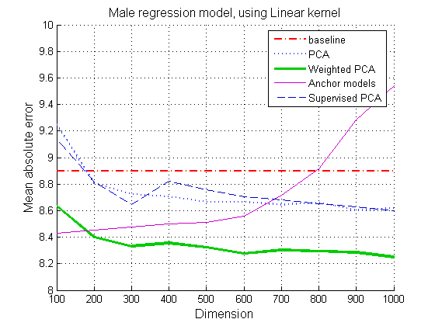
Figure ‎6-35: Regression performance (mean absolute error) vs. target dimension on male speakers using linear kernel.
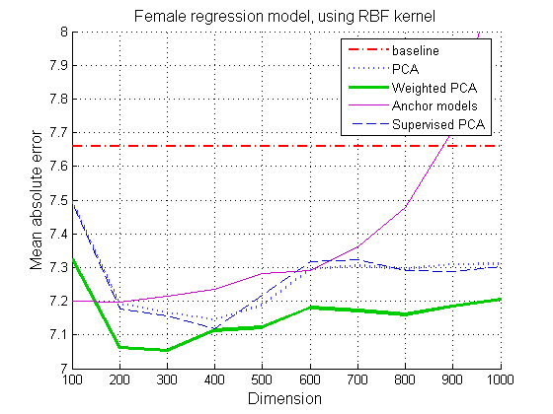
Figure ‎6-36: Regression performance (mean absolute error) vs. target dimension on female speakers using RBF kernel.
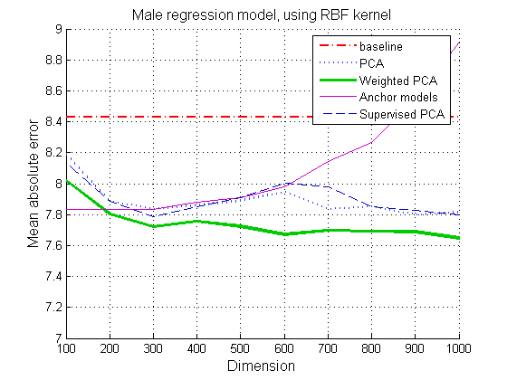
Figure ‎6-37: Regression performance (mean absolute error) vs. target dimension on male speakers using RBF kernel.
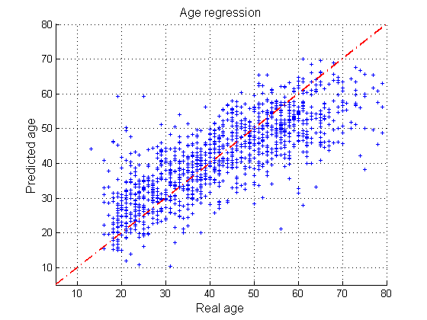
Figure ‎6-38: Regression testing results, real age vs. predicted age of the best regression model trained on female speakers and using RBF kernel. The feature vectors dimension is 300.
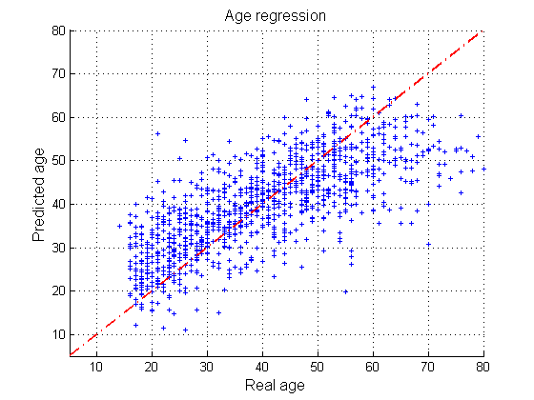
Figure ‎6-39: Regression testing results, real age vs. predicted age of the best regression model trained on male speakers and using RBF kernel. The feature vectors dimension is 600.

Speed measurements
Like for the classification, the total training and testing time reduces with a lower feature vector dimension. Figure ‎6-40 shows the average training time and Figure ‎6-41 shows the average testing time for each dimension. The SVM regression process is a bit longer than the SVM classification but there is also a drastic improvement in the training time when using low dimensional feature vectors. The training time of the baseline system using the full GMM supervectors takes 623 seconds, so when using a reduced feature vector of dimension 600, this time is 10 times shorter. The testing time is also reduced like shown in figure 6-26. The baseline system testing time is 1547 ms per supervector which is 6 times more than if using a reduced vector of dimension 600. The number of support vectors in the regression model is also reduced when using low dimensional feature vectors, but not as much as for the classification model.
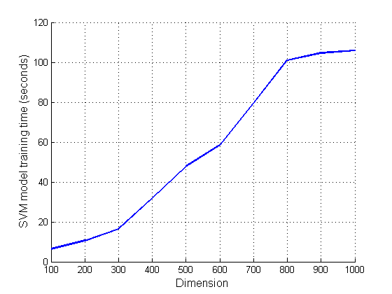
Figure ‎6-40: Average SVM regression training time (in milliseconds) per vectors dimension using RBF kernel. The baseline system time using feature vector dimension of 13312 is 623 seconds. (Running on an Intel™ Pentium IV).
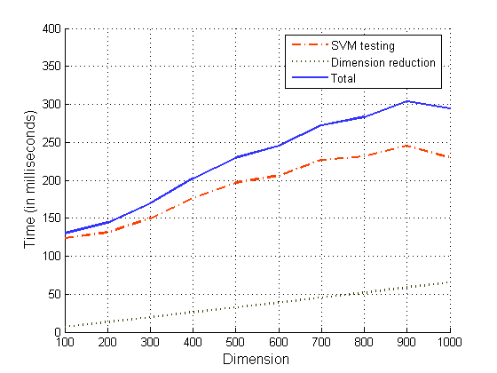
Figure ‎6-41: Average testing time (in milliseconds) per vectors dimension using RBF kernel. The baseline system time using feature vector dimension of 13312 is 1547 milliseconds. (Running on an Intel™ Pentium IV).

Conclusions
Two novel dimension reduction approaches were proposed and applied on the GMM supervectors for speaker age estimation. These approaches were implemented in two different systems, an age-group classifier and a precise age estimator by regression. In both systems, the SVM training and testing time is decreased when using low dimensional feature vectors. The use of the Gaussian RBF kernel is preferable to the linear kernel since it attained a better performance, even in the baseline system. The complexity involved in the RBF kernel calculation makes the dimensionality reduction imperative. Interestingly, experiments showed that the number of support vectors in the SVM model decreases when the feature vectors dimension is reduced. This phenomenon also contributes to the SVM testing speed-up and to the model’s robustness. An SVM model with fewer support vectors is less subject to overfitting since its VC dimension is smaller, leading to a diminished structural risk. As expected, in addition to the computation reduction, the dimension reduction approaches also improved the system’s accuracy. The performance achieved with the novel methods was higher than the baseline system and also better than standard techniques like PCA. The WPPCA approach was the most effective with consistent accuracy improvement in both the classification and regression. In the future we plan to explore non-linear kernel-based dimension reduction techniques.

References
- N. Minematsu, M. Sekiguchi and K. Hirose, “Automatic estimation of one’s age with his/her speech based upon acoustic modeling techniques of speakers”, In Proc. IEEE Int’l Conference on Acoustic Signal and Speech Processing, 2002, pp. 137–140.
- C. Muller, F. Burkhardt, “Combining Short-term Cepstral and Long-term Pitch features for Automatic Recognition of Speaker Age”, in Interspeech, Pittsburgh, PA, 2007.
- F. Metze, J. Ajmera, “Comparison of Four Approaches to Age and Gender Recognition for Telephone Applications”, in ICASSP, Honolulu, Hawaii, 2007.
- T. Bocklet, E. Noth, “Age and gender recognition for telephone applications based on GMM supervectors and support vector machines”. In ICASSP, vol. 1, 2008, pp. 1605-1608.
- A. Solomonoff, W. Campbell, and C. Quillen, “Channel compensation for SVM speaker recognition,” in Proc. Odyssey04, 2004, pp. 57–62.
- V. Robbie, K. Sachin and S. Sridha, "Discriminant NAP for SVM speaker recognition", In Odyssey-2008, paper 010.
- G. Dobry, R. Hecht, M. Avigal and Y. Zigel, “Dimension reduction approaches for SVM based speaker age estimation”, in Interspeech, Brighton, UK, 2009.
- S. Schotz, “A perceptual study of speaker age”, Dept. of Linguistics, Lund University, 2001, pp. 136-139.
- N. Minematsu, K. Yamauchi and K. Hirose, “Automatic estimation of perceptual age using speaker modeling techniques”, In Proc. of the Eighth European Conference on Speech Communication and Technology, Geneva, Switzerland, September 2003, pp. 3005–3008.
- D. Reynolds, T. Quatieri, and R. Dunn, “Speaker veriﬁcation using adapted Gaussian mixture models,” Digital Signal Processing, vol. 10, 2000, pp. 19–41.
- W. Campbell, D. Sturim, and D. Reynolds, “Support vector machines using GMM supervectors for speaker veriﬁcation,” IEEE Signal Processing Letters, vol. 13, no. 5, 2006, pp. 308–311.
- E. Noor, H. Aronowitz, "Efficient language Identification using Anchor Models and Support Vector Machines,“ in IEEE Odyssey, 2006, pp. 1-6.
- K. Pearson, “On Lines and Planes of Closest Fit to Systems of Points in Space”. Philosophical Magazine, 1901 pp 559–572.
- S. Lindsay, “A tutorial on Principal Components Analysis”, 2002.
- R. A. Fisher, “The Use of Multiple Measurements in Taxonomic Problems”, In Annals of Eugenics 7, 1936, pp 179–188.
- A. Genz, “Numerical Computation of Multivariate Normal Probabilities”, in J. of Computational and Graphical Stat., 1992, pp. 141-149.
- A. J. Smola and B. Scholkopf, “A Tutorial on Support Vector Regression”, Statistics and Computing, 2004
- E. Bair, T. Hastie, D. Paul, and R. Tibshirani, ”Prediction by supervised principal components”. Journal of the American Statistical Association, 2006, pp. 119-137.
- D. Sturim, D. Reynolds, E. Singer, and J. Campbell, “Speaker indexing in large audio databases using anchor models,” Proc. of ICASSP 2001.
- Y. Yang, M. Yang, and Z. Wu, “A Rank based Metric of Anchor Models for Speaker Verification”, in IEEE ICME, 2006, pp. 1097-1100.
- Y. Zigel, A. Cohen, “On cohort selection for speaker verification”, in EUROSPEECH, 2003, pp. 2977-2980.
- B. Boser, V. N. Vapnik. 1992. A training algorithm for optimal margin classiﬁers. In COLT’92: Proceedings of the ﬁfth annual workshop on computational learning theory, pages 144–152, New York, NY, USA. ACM Press.
- H. Drucker, C. Burges, L. Kaufman, A. Smola and V. Vapnik. “Support Vector Regression Machines”. Advances in Neural Information Processing Systems 9, 1996, pp 155-161.
- R. Dehak, N. Dehak, P. Kenny, and P. Dumouchel, “Linear and Non Linear Kernel GMM SuperVector Machines for Speaker Veriﬁcation”, in Interspeech, Antwerp, Belgium, 2007.
- L. Kaufman, “Solving the quadratic programming problem arising in support vector classiﬁcation”, in Advances in Kernel Methods - Support Vector Learning, Bernhard Scholkopf, Chrisopher J.C. Burges and Alexander J. Smola (eds.), MIT Press, Cambridge, MA, 1998.
- F. Rong-En, C. Pai-Hsuen, L. Chih-Jen, “Working Set Selection Using Second Order Information for Training Support Vector Machines”, Journal of Machine Learning Research 6, 2005, pp. 1889–1918.
- J. C. Platt. Fast training of support vector machines using sequential minimal optimization. In B. Scholkopf, C. J. C. Burges, and A. J. Smola, editors, Advances in Kernel Methods - Support Vector Learning, Cambridge, MA, 1998. MIT Press.
- C. Chih-Chung, and L. Chih-Jen, LIBSVM : a library for support vector machines, 2001. Software available at http://www.csie.ntu.edu.tw/~cjlin/libsvm
- R. Collobert and S. Bengio. Svmtorch: Support vector machines for large-scale regression problems. Journal of Machine Learning Research (JMLR), 1:143–160, 2001.
- G. Rossum and F. Drake. Python Reference Manual, Python Software Foundation, 2006 http://docs.python.org/ref/ref.html.
- E. Jones, T. Oliphant and P. Peterson “Scipy: Open source scientific tools for Python”, 2001, http://www.scipy.org/.
- S. Young, G. Evermann, “The HTK Book”, Cambridge University Engineering Department, 2002.

